Name | Singh Suryansh Alok Kumar
UID no. | 2022300119
Experiment No. | 3- Program 2&3

AIM: | Problem Solving Using Object Oriented Programming
Program 1
PROBLEM STATEMENT : | A program to simulate a simple banking system in which the initial balance and rate of interest are read from the keyboard and these values are initialised using the constructor member function. The program consists of the following methods:  - To initialise the balance amount and the rate of interest using constructor member function  - To make deposit  - To withdraw an amount for the balance  - To find compound interest based on the rate of interest  - To know the balance amount  - To display the menu options
THEORY: | Switch- Case:  In Java, the switch statement is used to evaluate a variable or expression against a set of values and execute a block of code based on the matched value. It is commonly used as an alternative to a series of "if-else" statements.  Constructor:  In Java, a constructor is a special method that is used to create and initialize objects of a class. It is called automatically when an object is created and is used to set the initial values of the object's member variables.  Here are some key concepts to keep in mind about constructors in Java:  - Constructor name: The name of the constructor is always the same as the name of the class.  - No return type: A constructor does not have a return type. This is because the main purpose of a constructor is to create and initialize an object, not to return a value.  - Overloading: Constructors can be overloaded, which means that you can define multiple constructors with different parameter lists. This allows you to create objects with different initial values depending on the arguments passed to the constructor.  - Default constructor: If you do not define any constructors for a class, Java will automatically provide a default constructor with no arguments. However, if you define any constructors explicitly, the default constructor will not be created unless you define it explicitly.  - Access modifiers: Constructors can have access modifiers (public, private, protected) to control the visibility of the constructor to other classes.  - Initialization of member variables: The purpose of a constructor is to set the initial values of the object's member variables. This is usually done using parameters passed to the constructor or by assigning default values to the member variables.  - Chaining constructors: In Java, you can call one constructor from another constructor using the "this" keyword. This is called constructor chaining and is used to avoid code duplication when defining overloaded constructors.  Overall, constructors are an important part of object-oriented programming in Java, as they are used to create and initialize objects with the appropriate initial values. By understanding the key concepts of constructors, you can create classes that are flexible and easy to use in your Java programs.  Java.Lang.Math:  In Java, the java.lang.Math class provides a set of mathematical functions that can be used for various purposes, such as rounding, trigonometry, exponential and logarithmic operations, and more. The Math class is part of the Java standard library and does not require any external dependencies.  Here are some of the key features and functions provided by the Math class:  - Constants: The Math class provides constants like PI and E, which can be used for trigonometry and exponential operations respectively.  - Trigonometric functions: The Math class provides trigonometric functions like sin, cos, tan, and their inverse counterparts asin, acos, and atan.  - Exponential and logarithmic functions: The Math class provides functions like exp, log, log10, and pow, which can be used for exponential and logarithmic operations.  - Rounding functions: The Math class provides functions like ceil, floor, and round, which can be used to round off decimal values to the nearest integer.  - Random numbers: The Math class provides a random function, which returns a pseudorandom number between 0.0 and 1.0.  - Utility functions: The Math class also provides functions like abs, max, and min, which can be used for various arithmetic and logical operations.
PROGRAM: | /*A program to simulate a simple banking system in which the initial balance and rate of  interest are read from the keyboard and these values are initialised using the constructor  member function. The program consists of the following methods:  -To initialise the balance amount and the rate of interest using constructor member function  -To make deposit  -To withdraw an amount for the balance  -To find compound interest based on the rate of interest  -To know the balance amount  -To display the menu options  */  //Importing required classes  import java.lang.Math;  import java.util.Scanner;  //Creating Main class  public class Bank {  public static void main(String[] args){  //Taking input from the user  Scanner sc= new Scanner(System.in);  System.out.println("Enter the account balance: ");  int b= sc.nextInt();  System.out.println("Enter the intrest: ");  int i= sc.nextInt();  //Creating a object of "information" class  information acc= new information(b,i);  //Calling the menue function  acc.menue();  sc.close();  }  }  class information{  Scanner sc= new Scanner(System.in);  int balance;  int intrest;  //Setting the balance and intrest  public information(int x,int y)  {  balance=x;  intrest=y;  }  //Switch case for menue options  public void menue()  {  System.out.println("Welcome to Our Bank!!!");  System.out.println("Enter 1 for Viewing your Current balance.");  System.out.println("Enter 2 for Depositing Money.");  System.out.println("Enter 3 for Withdrawing Money.");  System.out.println("Enter 4 for Calculating Compound intrest.");  int a= sc.nextInt();  int z;  switch(a)  {  //View Balance  case 1:  view();  break;  //Deposit  case 2:  deposit();  break;  //Withdrawal  case 3:  withdraw();  break;  //Coumpound Intrest  case 4:  System.out.println("Enter the Period for Intrest and its frequency: ");  int t=sc.nextInt();  int f= sc.nextInt();  compound_intrest(t, f);  break;  default:  System.out.println("Enter a valid number.");  }  //Recalling the switch case for further operations  System.out.print("Enter 1 to manage your account: ");  z= sc.nextInt();  if (z==1) menue();  else System.out.println("Thank you!!!");  }  //Deposition methord  public void deposit()  {  int d;  System.out.println("Enter the amount to be deposited: ");  d= sc.nextInt();  balance+=d;  }  //Withdrawal Methord  public void withdraw()  {  int d;  System.out.println("Enter the amount to be withdrawed: ");  d= sc.nextInt();  if(balance>=d)  balance-=d;  else  System.out.println("Insuffficient funds.");  }  //Methord to see current account balance  public void view()  {  System.out.println("Your current acc balance is: " + balance );  }  //calculate intrest amount on current account balance  public void compound_intrest(int t,int n)  {  double r = intrest/100.0;  double a = (1+(r/n));  double p = Math.pow(a,(n*t));  double c = balance*p-balance;  System.out.printf("The Compound intrest on your current balance for %d Years is %.2f\n" ,t,c);  }  }
RESULT:
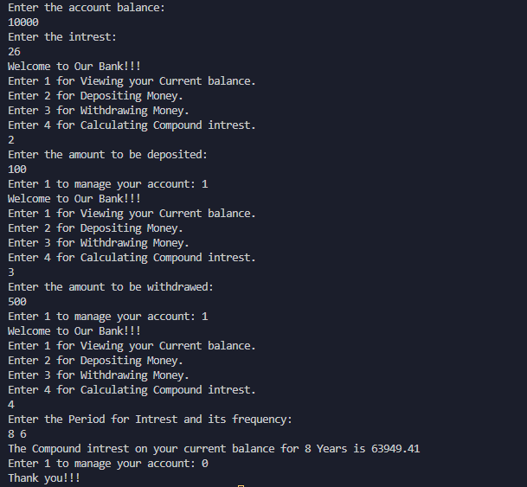
Program 2
PROBLEM STATEMENT : | Create a Class Area with length as data member. Create 2 constructors  (No args and 2 args) and a methord to calculate circumference
THEORY: | Constructor Overloading:  In Java, constructor overloading is a technique where multiple constructors can be defined for a class, with each constructor taking a different set of parameters. This allows objects of the same class to be created in different ways, depending on the arguments passed to the constructor.  Constructor overloading is similar to method overloading, where multiple methods with the same name can be defined in a class, but with different parameter lists.  example, the Person class has three constructors:  - The first constructor has no parameters and sets the name to "Unknown" and the age to 0.  - The second constructor takes a name parameter and sets the name to the value of the parameter, and the age to 0.  - The third constructor takes both name and age parameters and sets the name and age to the values of the parameters.  .Close():  In Java, the .close() method is used to release any resources that were acquired by an object, such as files, network connections, or database connections. This method is typically used with objects that implement the AutoCloseable or Closeable interfaces.  When an object is created that uses resources, such as a file input stream or a database connection, the resources are allocated by the operating system. If the resources are not released properly, it can lead to memory leaks and other issues. The .close() method ensures that the resources are released properly, even if an exception occurs during the execution of the program.
PROGRAM: | /*Create a Class Area with length as data member. Create 2 constructors  (No args and 2 args) and a methord to calculate circumference*/  //Importing required classes  import java.util.Scanner;  //Creating a constructor  class Area{  int length;  int breath;  //Constructor overloading with 1 parameter  public Area(int x)  {  length=x;  breath=x;  }  //Constructor overloading with 2 parameter  public Area(int x,int y)  {  length=x;  breath=y;  }  //Default Condition  public Area()  {  System.out.print("PUT SOMETHING!!!");  }  //Methord to calculate area  public int area()  {  int area=length*breath;  return area;  }  }  public class Shape {  public static void main(String[] args)  {  Scanner sc= new Scanner(System.in);  int a;  int b;  //Taking length and breath as inputs  System.out.println("Enter the length: ");  a=sc.nextInt();  System.out.println("Enter the breadth: ");  b=sc.nextInt();  //Creating objects and constructors  Area sq=new Area(a);  Area rect=new Area(a,b);  //Display the area  System.out.println("The area of the square is: " + sq.area());  System.out.println("The area of the square is: " + rect.area());  sc.close();  }  }
RESULT:
